How To Download E-Books
- Click on E-Books icon at the bottom of the Researcher screen to find the e-book you would like to download.

- Hit the “Click here to view book” link .

- When the log in comes up, begin typing Hobbs and all the Hobbs schools will appear on the list. Choose Hobbs High School.

- After choosing Hobbs High School, type in the user as Hobbs and the password as Eagles.

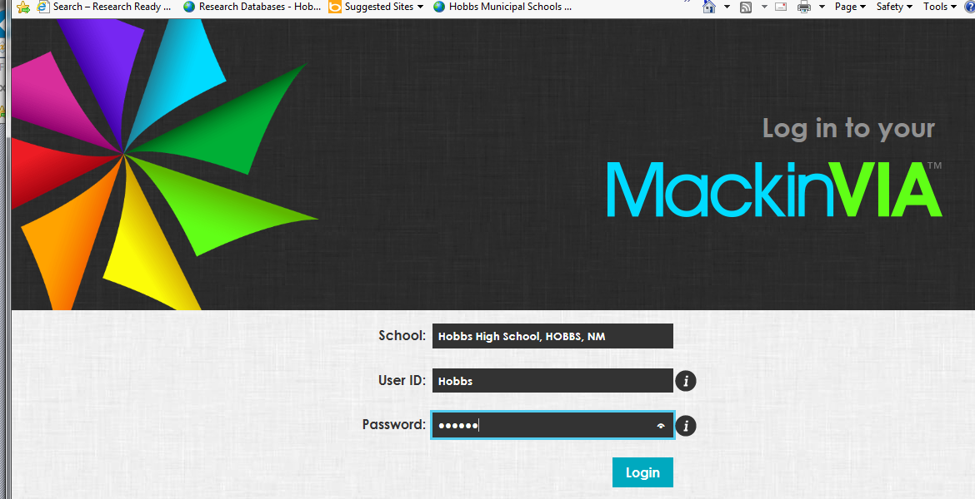

- After logging in, the book information will appear on the screen. In order to check out any books, you must register and set up a backpack. You will only have to register once.

- To register, fill out the information below. After you register once, you will no longer have to register again; you will just login instead of register.

Your User ID is just as you log in to the computers at school…. Your last name and then your first name. The password is your student ID number. Please type your password in again to confirm it, type in your email address and fill in your first name. Then hit the register button and you will be registered.
- Click the X to get out of the backpack and then hit the checkout button to check out the book.
The due date is listed. If you are not finished reading the book by the due date listed, go in to your backpack and renew your book. Hit the Open Now button to download the book.

